CloudEngine Switches Openflow deployment Guide

| Acronyms and Abbreviations | Full Name |
| --- | --- |
| LXC | Linux Container |
| CE | Cloud Engine switch |
| VRPV8 | Versatile Routing Platform Version 8 |
|  |  |
|  |  |

# introduction

VRP is a network OS incorporating Huawei proprietary intellectual properties and capable of supporting various network systems of Huawei.

Huawei CloudEngine switches support LXC based on Linux OS so as to run customized applications such as OVSDB, Puppet agent, ZTP, Openflow.

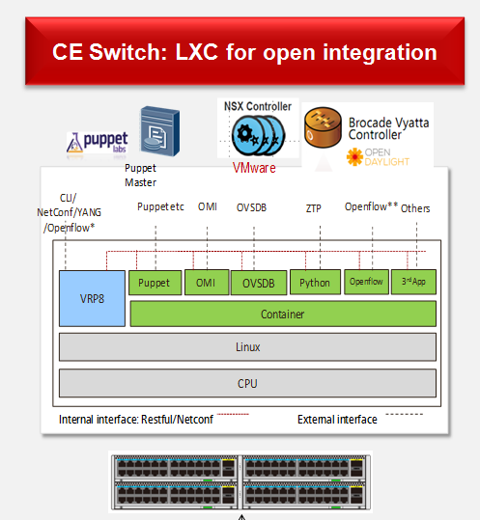

# Design guide

# Implememtation guide

## STEP1: Install container in CloudEngine switch

### Install lxc Root filesystem :

<HUAWEI>system-view

Enter system view, return user view with return command.

[~HUAWEI]bash shell rootfs_openflow.sqfs disk-size 100

[*HUAWEI]commit

Committing...........done.

[~HUAWEI]

## STEP2: Configure IP connection between container and external network



### Configure IP address of virtual ethernet port of CE switch

[~HUAWEI] port create virtual-ethernet 1/0/0

[~HUAWEI]interface ethernet 1/0/0

[~HUAWEI-Ethernet1/0/0]ip address 192.168.90.1 24

[~HUAWEI-Ethernet1/0/0]commit

[~HUAWEI-Ethernet1/0/0]

### Log in container :

[~HUAWEI]bash

Type <Ctrl+a q> to exit the console, <Ctrl+a Ctrl+a> to enter Ctrl+a itself

Please press Enter to activate this console.

huawei login: root

Password:

### Configure IP address of lxc eth0-port (user :root, password :root)

Modify vim /etc/network/interfaces to configure eth0 IP address：

root@huawei:~# vim /etc/network/interfaces

*auto eth0*

*iface eth0 inet static*

*address 192.168.90.2*

*netmask 255.255.255.0*

*gateway 192.168.90.1*

Active configure by reboot eth-port：

root@huawei:~# /etc/init.d/networking restart

### The router need to be advertised to external network to ensure the IP reachablility between LXC eth0 and openflow controller.

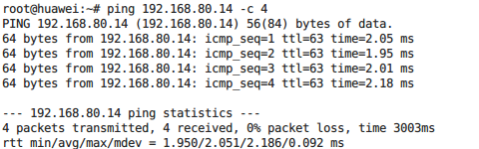

## STEP3: VRPV8 configure :

### Configure netconf ：

sys  
aaa  
local-user rootDC password irreversible-cipher Admin@123  
local-user rootDC user-group manage-ug  
local-user rootDC level 3  
local-user rootDC service-type ssh  
comm  
q  
ssh user rootDC  
ssh user rootDC authentication-type password  
ssh user rootDC service-type all  
ssh user rootDC sftp-directory flash:

ssh server cipher aes256_ctr aes128_ctr aes256_cbc aes128_cbc 3des_cbc blowfish_cbc

ssh server hmac sha2_256_96 sha2_256 sha1 sha1_96  
commit  
stelnet server enable  
snetconf server enable  
rsa local-key-pair create  
commit  
netconf  
idle-timeout 0  
commit

ssh client first-time enable

Note：For security, the following conditions are recommanded for netconf user password :

The password must be at least 8 characters long ;

The password must contain numbers, letters, and special symbols.

### Save VRPV8 configures, then the device will not need to re-configure even after rebooted.

## STEP4: Install openflow in container:

### Log in the container by SSH as root user ;

### ftp or scp download **openflow-1.3.4.deb**.

### Install **openflow-1.3.4.deb**:

*dpkg -i openflow-1.3.4.deb*

## STEP5: Configure and run openflow in container:

### Log in the container by SSH as root user ;

### Modify configure：

1. vim /home/ofdatapath.cfg
2. Start ofdatapath：

*ofdatapath enable ptcp:6677 -d 000000000020 -I 192.168.90.1 -f /home/ofdatapath.cfg*

-d : openflow switch ID ;

-I : IP address of virtual ethernet port of CE switch ;

1. Start ofprotocol：

*ofprotocol tcp:127.0.0.1:6677 tcp:192.168.80.14:6633*

tcp :192.168.80.1 : IP address of openflow controller ;

## STEP6: Show openflow flow table:

dpctl tcp:127.0.0.1:6677 stats-flow